

Clarity

**Development Environment Setup**

25/10/2013

**Table of Content**

.

1. Source code 3

2. Install pre-requisites 4

2.1 IDE 4

2.2 Packages 4

2.3 Database 4

# Source code

Follow below steps to get source code:

1. Sign in Team Foundation Server with Microsoft/Hotmail account
2. Request to be added as team member
3. Install Visual Studio 2012
4. Connect to TFS at <https://epinion.visualstudio.com>
5. Get Clarity project

# Install pre-requisites

## IDE

* Microsoft Visual Studio Premium 2012
* Visual Studio extensions (available from within VS unless otherwise noted)
  + Web Essentials 2012
  + TestDriven.NET (Personal Edition)
  + NUnit Test Adapter
  + SpedFlow
  + TypeScript: <http://www.microsoft.com/en-us/download/details.aspx?id=34790>
  + Optional: VSColorOutput
  + Optional: Productivity Power Tools 2012
* Gulp to combine js and css files:

<http://www.davepaquette.com/archive/2014/10/08/how-to-use-gulp-in-visual-studio.aspx>

1. Install Node and Gulp: download and install node.js which includes npm (skip this step if you are using VS2015 and .NET 5.0)
2. Run command line npm install gulp –g
3. Run the following commands from same folder of project
   * npm install gulp --save-dev
   * npm install gulp-concat --save-dev
   * npm install gulp-uglify --save-dev
   * npm install del --save-dev
   * npm install gulp-clean-css --save-dev
4. Run: **gulp watch**

* Optional: NUnit (for GUI runner)

## Packages

All packages included in project by default (no need to download and set up manually). NuGet packages will be downloaded on build.

## Database

Install Microsoft SQL Server 2008 R2 Enterprise (using default instance name)

* Database Engine
* Analysis Services

Configure Logins in Database Engine:

* Add [**NT AUTHORITY\LOCAL SERVICE**] user to Security\Logins as below screenshot

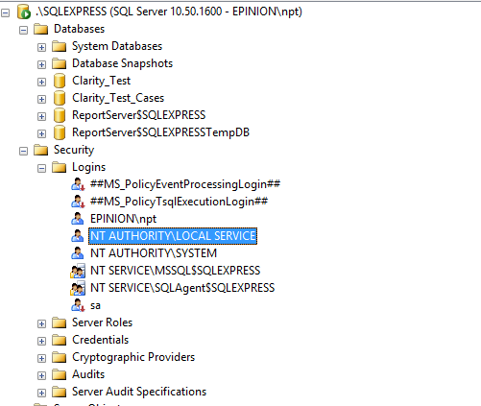

* Grant the user **sysadmin** permission

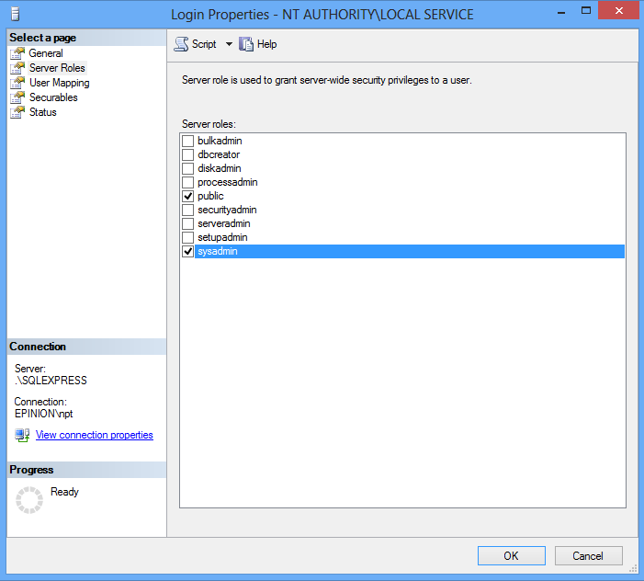

# Publish to Elastic Beanstalk

Go to <http://aws.amazon.com/visualstudio/>

Download AWS Toolkit for Visual Studio